

**DEPARTMENT** **OF ELECTRICAL AND ELECTRONICS ENGINEERING**

# **SMART SHOPPING CART WITH AUTOMATED BILLING SYSTEM**

A MINI PROJECT REPORT

*Submitted by*

*VIKRAM.S (1NH18EE061)*

*JIBRAN ZAIDI HUSSAIN.C (1NH18EE022)*

*NIRUPAVARDHAN REDDY (1NH18EE027)*

***In partial fulfilment for the award of the degree of***

BACHELOR OF ENGINEERING

IN

ELECTRICAL AND ELECTRONICS ENGINEERING



**DEPARTMENT OF ELECTRICAL AND ELECTRONICS ENGINEERING**

**BONAFIDE CERTIFICATE**

This is to Bonafide that the mini project report entitled “**SMART SHOPPING CART WITH AUTOMATED BILLING SYSTEM**” submitted by **Vikram.S, jibranZaidi**, **Nirupavardhan.L** Department of Electrical and Electronics Engineering, New Horizon College of Engineering, Bangalore in partial fulfilment for the award of the degreeof Bachelor of Engineering, is a record of bonafide work carried out by him/her under my supervision, as per the NHCE code of academic and research ethics.

The contents of this report have not been submitted and will not be submitted either in part or in full, for the award of any other degree or diploma in this institute or any other institute or university. The project report fulfils the requirements and regulations of the institution and in my opinion meets the necessary standards for submission.

|  |  |
| --- | --- |
| Signature of Guide  **(Dr.Muni Prakash)** | Signature ofHOD  **(Dr.Mahesh.M)** |



Autonomous College Permanently Affiliated to VTU, Approved by AICTE & UGC Accredited by NAAC with ‘A’ Grade, Accredited by NBA

**Acknowledgement**

With immense pleasure and deep sense of gratitude, I wish to express my sincere thanks to my supervisor **Mrs**.**Deepa V Bolanavar ,** Head of the Department, Electrical and Electronics Engineering, New Horizon college of Engineering, without his motivation and continuous encouragement, this mini project would not be have been successfully completed.

It is indeed a great pleasure to recall the people who have helped us in carrying on this project Naming all the people who have helped us in achieving this project would be impossible, Yet I thank a selected few who have helped me in diverse ways.

We wish to excess our sincere gratitude to Dr.Manjunatha, Principal, NHCE, Bangalore for providing me with facilities to carry out this project.

We wish to express our sincere gratitude to our teacher and guide Dr Ram Kumar (HOD) NHCE for his valuable suggestions, guidance, care and attention shown during the planning, Conduction stage of this project work.

We express our sincere thanks to project coordinator, all the staff members and non-teaching staff of Department of Electrical and Electronic Engineering for the kind of cooperation extended by them.

**ABSTRACT**

A supermarket is a place where customers come to purchase their daily using products and pay for that. So there is a need to calculate how many products sold and generate the bill for the customer.

When we go to shopping mart for shopping, we have to work for selecting the right product. Also, after that, it is hectic to stand in line for billing all the goods. Hence, we are proposing to develop a smart shopping cart system that will keep the track of purchased products and also online transaction for billing using RFID and ZigBee. In this system, every product in Mall or Mart will have RFID tag, and every cart will be having RFID Reader and ZigBee attached to it. There will be a centralized system for the recommendation and online transaction. Moreover, also there will be RFID reader at the exit door for anti-theft*.*

There has been an emerging demand for quick and easy payment of bills in supermarkets. This project describes how to build an automated and time saving system for the world of retail which will make shopping experience impetuous, customer friendly and secure. In this paper, smart cart is proposed that will be capable of generating a bill from the cart itself. The customer will make the payment in no time through a rechargeable credit card which will help to maintain database and introduce schemes and offers in stores accordingly. This smart cart uses RFID technology for shopping and payment, AVR microcontroller for peripheral interfacing and inventory management. This innovative system will help the stores to see a rise in their sales along with delighting customers.

***KEYWORDS — AVR Microcontroller, RFID technology (products, card and tags), Retailing system.***

|  |  |  |
| --- | --- | --- |
| **Sl No.** | **Table of Contents** | **Pg No.** |
| **1.** | **Introduction** | **1** |
| **2.** | **Theory** | **1** |
| **3.** | **Components Description** | **2** |
| **4.** | **Working of Project** | **4** |
| **5.** | **Circuit Diagram** | **1** |
| **6.** | **Principle of Operation** | **5** |
| **7.** | **System Architecture** | **1** |
| **8.** | **Proposed Methodology** | **3** |
| **9.** | **Hardware Pictures** | **1** |
| **10.** | **Applications** | **1** |
| **11.** | **Conclusion** | **1** |
| **12.** | **Reference** | **1** |

**INTRODUCTION**

Ever since the debut of wireless technology, electronic commerce has developed to such an extent to provide convenience, comfort, and efficiency in day-to-day life. The main purpose of this paper is to provide centralized and automated billing system using RFID and ZigBee communication. ZigBee module1. There will also be a centralized database from which we can give product recommendation to the customer.

Current development in chip manufacturing technology increases practical approach for new applications. Fast growth in RFID technology is making impact on many industries1.

The centralized database will give product recommendation and information about the product on the LCD screen present on the shopping cart, which will help the customer in buying products. LCD can display characters, numbers, and graphics. LCD show the running bill.

The purpose of this paper is to provide an automatic billing system by using RFID and ZigBee to avoid the queue and save time in malls and super markets & to give product recommendation and information with Anti-Theft.

Each product of shopping mall, super markets will be supplied with an RFID tag, Every cart contains PID (Product Identification Device). Specifically, PID contains a microcontroller, LCD, an RFID reader, EEPROM, and sample extension of this system would be to use RFID embedded in consumers’ loyalty cards to identify individuals. This option could be useful for faster login to the system and to charge the shopping cost directly to the customer account at the point-of-sale.

## **Theory**

## 

## Smart Cart using Arduino and RFID is an efficient system when it comes to scanning of products, bill generation and payment. It uses an Arduino chip, a RFID reader, an LCD, buzzers, capacitors, buttons, etc. and also RFID tags to be attached on the products.

The RFID reader shall be used to scan the RFID tags present on the product and all the information received from the tags shall be stored in the Arduino chip. The system shall have 3 buttons- total, delete and bill button. The product can be directly scanned by the reader and if the customer wishes to remove any product, they just have to press the delete button and scan the product again. The product shall be deleted. If the customers wish to see the total, they can press the total button and the total shall be displayed. While making the payment of the bill, the customers just has to press the bill button after connecting the USB to the billing section and their bill shall be automatically generated in the admin’s system.

The following block diagrams give a brief idea about the connections and the working at the trolley side as well as the billing side.

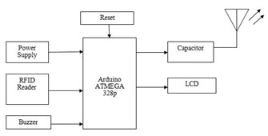

**Fig.1 Proposed System (Trolley section)**

## **IMPLEMENTATION OF THE SYSTEM**

## The smart cart can be implemented in the following way in the store.

## **Stage I**(Refer)

registered by using the product registration form, wherein information about the product like product name, product brand, colour, RFID tag number, cost and product ID number are added.

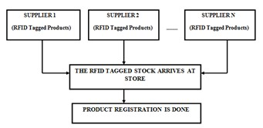

**Fig.2 Block Diagram of Stage I**

**Stage II** (Refer)

The customer arrives at the store. There can be two cases:

* If a new customer arrives to the store then he will move to the user registration counter. User will be registered and a RFID rechargeable loyalty card is issued. The customer will then take the smart cart which is already locked and start shopping.
* If an old customer arrives to the store he can get his RFID loyalty card recharged and proceed to the shopping with the smart cart.

**Stage** **III** (Refer)

When the customer is done with the shopping, he will move forward along with the cart to the billing counter. At the billing section cart is connected to the server via the serial port and is authenticated which results in opening of the cart. The data of the purchased RFID tagged products is automatically transferred to the server. The bill is computed and customer is provided with a facility to remove undesired products.

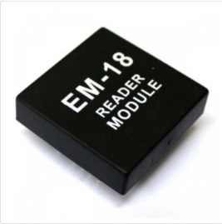 **Components Description**

1. **RFID Reader** –

Radio Frequency Identification (RFID) reader (EM-18) is the wireless non-contact use of radio-frequency electromagnetic fields to transfer data, for the purposes of automatically identifying and tracking tags attached to objects. The tags contains electronically stored information. This EM-18 RFID Reader is a tiny, simple to use RFID reader module. With built-in antenna, the only holdup is the 2mm pin spacing.

**Product Identification Device** – It is a board category of labelling that includes functions such as product traceability, brand protection, and various information labels.

*\*****LCD*** **16x2 Display**–

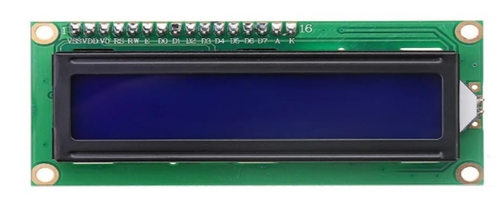

LCD is a flat-panel display or other electronically optical device that uses the light modulating liquid crystals combined with polarizers. Liquid crystals do not emit light directly, instead using a backlight or reflector to produce imaged in colour or monochrome.

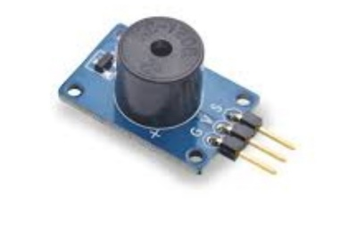 *\*****Buzze****r –*

A buzzer is audio signalling device, which consists of an outside case with two pins to attach it to power and ground. When current is applied to the buzzer it causes sound that we hear.

1. **Zigbee Module**- It is specified for higher level communication protocols using small, low power digital radios based on IEEE 802.15 standard for personal area networks. It is used for networking and it doesn’t need high data transfer rate. It operates at various frequencies such as 868 MHz, 902-968 MHz and 2.4GHz. Since it requires low power from device
2. **Arduino Nano**

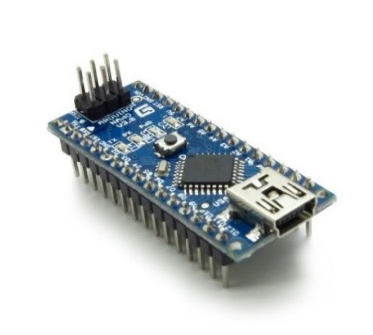

It is a small, complete and breadboard friendly board based on the ATmega328. It has got more or less the same functionality of Arduino, but in a different package. It lags DC power jack and works with Mini-USB cable instead of standard one.

1. **PCB Board** – It is a printed circuit Board which mechanically supports and electrically connects electrical or electronic components using conductive tracks and connecting different components on PCB, Such as transistors, resistors and integrated circuits.
2. **RFID Tags**- RFID Tags are a type of tracking system that uses smart barcodes in order to identify items. RFID is short for “radio frequency identification”, and as such, RFID tags utilize radio frequency technology
3. **Female Header Pin-** This is a pin header is a form of electrical connector. The female counterparts are sometimes known as a female socket header, though there are numerous naming variations of male and female connectors.

**Working of Project**

The developed system comprises of ARM7 microcontroller, 16x2 LCD display unit, RFID reader, RFID tags, ZIGBEE transceiver and a battery power source.

All the items in the mall will be equipped with RFID tags. When a person puts any item in the trolley its code will be detected and that code is send to the master billing counter, in the master billing counter side we are using PC, to store all the data base. Once the PC receives that code it sends the particular product cost to the controller part, price of that item will be stored in memory. As we put the items, the costs will get added to total bill. Thus, the billing will be done at the trolley itself. For detecting different items RFID reader will be used. RFID tags are used to uniquely identify products respective details. LCD is used to display item names, item cost etc. An embedded system is one that has computer-hardware with software embedded in it as one of its most important components. Today purchasing various items in malls or supermarkets require a trolley. On each occasion, customer has to pull the trolley from one rack to another rack, for collecting items and simultaneously customer has to perform estimated expense computation. After total purchase, the customer needs to go to billing counter for payments. At billing counter, the cashier scans the products using barcode reader which is very time-consuming process and results in long queue at billing counter. In this concept each and every product has RFID tag instead of barcodes and the smart trolley will consists of a RFID reader, LCD display and ZIGBEE transmitter.

Whenever a product is purchased it automatically checks for the expiry date. So, it helps us to remove the expired product. Navigation facility helps us to locate the items which we want. The customer will be able to know all the details of the items in the trolley itself, that is displayed on the LCD of the trolley.

All the product information is stored in a database at a central server. The information received from the server is temporarily stored in the shopping cart memory and then displayed on the display unit affixed on the cart. As the products are selected and added into the cart, the RFID reader will identify the product and the price will be added to the temporary bill. If the customer need to ‘cancel’ a selected product, it can be accessed through swiping the product tag two times. After completing the shopping, the customer has to select the “Finish” button.

1. 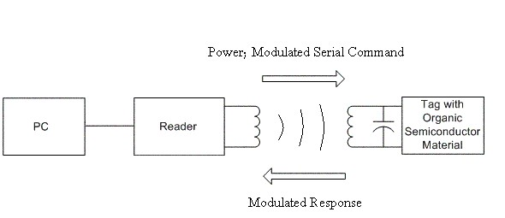**RFID SYSTEM DETAILS**

**Fig.3 RFID Module Setup**

Radio-frequency identification (commonly abbreviated to RFID) is because it relates to the identification of objects using EM radiation at radio frequencies. In Table 2 we saw that a large range of frequencies within the EM spectrum are referred to as radio Frequencies (RF), which results in a number of different forms of RFID.

Once again, RFID systems may be categorized based on the band of the EM spectrum that they operate in. RFID systems in the same band will generally display similar characteristics; those in other bands may well operate very differently and therefore be more or less suitable for a given application. An RFID system comprises two components – an RFID reader and an RFID tag. Despite its name, the RFID reader is really the transmitter in an RFID system. The electronics in the reader uses an external power source to generate the signal that drives the reader’s antenna and which in turn creates the appropriate radio wave.

This radio wave may be received by an RFID tag, which in turn

‘reflects’ some of the energy it receives in a particular way (based on the identity of the tag). Whilst this reflection is going on, the RFID reader is also acting as a radio receiver, so that it can detect and decode the reflected signal in order to identify the tag.

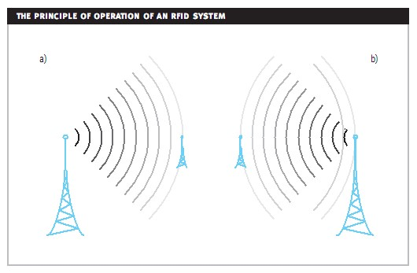**PRINCIPLE OF OPERATION IN RFID SYSTEM**

An RFID system is specifically designed to be asymmetric – the reader is big, expensive and power hungry compared to the RFID tag. There are a number of different types of RFID system, but one basic categorization is based on the power source used by the tag

Passive tag RFID systems require no power source at the tag – there is no battery. Instead, the tag uses the energy of the radio wave to power its operation, much like a crystal radio. This results in the lowest tag cost, but at the expense of performance.

Semi-passive tag RFID systems rely on a battery built into the tag in order to achieve better performance (typically in terms of operating range). The battery powers the internal circuitry of the tag during communication, but is not used to generate radio waves.

Active tag systems use batteries for their entire operation, and can therefore generate radio waves proactively, even in the absence of an RFID reader.

Passive tag RFID systems are the most common type, and are often referred to simply as ‘RFID systems’.

1. **RANGE OF RFID SYSTEM**

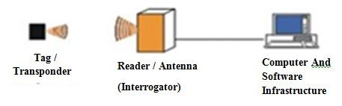

**Fig.4 RFID Ranging**

With an RFID system, the term range naturally refers to the maximum operating distance between the reader antenna and the tag, and the field of the reader is the specific operating area. The frequency of operation used for an RFID system has a big effect on the operating range. Analysis of the physics of RFID communications shows that the optimum frequency is around 400-500MHz [9]. Such analysis cannot be made generically - there are a number of factors to take into account and these will have different effects based on the intended application. Example factors that will be affected by the choice of frequency include: size of tag antenna, ease of power delivery to the tag, ease of communication of tag back to reader, cost and speed of communication.

The range of RFID systems operating in the UHF band is governed

largely by the principles outlined. This means that the ability of the reader to power and communicate to the tag is based on the inverse square law (1/r), as will the return path of reflected signals from the tag to the reader.

Operation will also be affected by environmental conditions and interference from other radio sources at the same frequency. RFID systems that operate in the HF band of the spectrum work in a very different way to those using the UHF band and it is useful to understand this fundamental difference and the effect it has on operating range. If communication occurs over a short distance, relative to the wavelength of the radio wave, this is said to be near-field operation. Since HF (330MHz) RFID systems use waves with a wavelength of around

10-100m, if the distance of the communication is much less than this (which is the case in RFID) then this is a near-field communication. Nearfield communication is based on a magnetic field effect, which has an inverse sixth power (1/r) relationship with range.

Of course, if a directional antenna is used, its radiation pattern will also affect the reader field.

RFID consists of two parts:

1. *RFID tags* - Passive RFID tags for products-Passive RFID tags are attached to the products and are scanned by the reader attached to the cart. The data (product name, RFID number and cost) corresponding to respective card gets displayed on the LCD.

Passive RFID tags for user – RFID credit cards are of great advantage because they permit contactless payment transactions which are fast, easy, can be more reliable than magstripe transactions, and require only physical proximity (rather than physical contact) between the credit card and the reader. RFID based credit cards are issued to the user at the time of registration and the card is recharged with money.

Other important user information like customer name, contact number, email id, RFID number and balance are also entered.

1. *RFID Reader* - RFID reader (EM-18) is installed in the cart which scans the products which pass through the inlet and are entered to the cart. After reading the RFID number corresponding data about the product gets displayed on the LCD.

LCD

1

2

3

4

5

6

7

8

9

10

11

12

13

14

15

16

VCC

8 Bit Data Bus of LCD To MCU

Port

Control Pins of

LCD To MCU Port

Pins

**Fig.5 Pin Configuration of LCD**

**MAX 232 Module-**

This chip is used when interfacing micro controller with PC to check the Baud rate and changes the voltage level because micro controller is TTL compatible whereas PC is CMOS compatible. The MAX 232 IC contains the necessary drivers and receivers, to adapt the RS- 232 signal voltage levels to TTL logic.

RS 232 is used at the time of billing. Cart is connected to the laptop via MAX 232 and after connection is made details about the purchases are transferred to the laptop and lock is opened. The bill is calculated and it is debited from the user RFID credit card and process is complete.

*Cart locking mechanism*- For locking the cart motor is used along with motor driver L293D. To derive the DC geared motor near about 50-100 mA current is required. But any I/O pin of any MCU can source/sink a current of near about 20 mA. So for its interfacing with microcontrollers a power or current amplifier circuit is required, known as motor driver circuits L293D is used which is a H bridge IC to control the direction of motor rotation.

**3. POWER SUPPLIES**

The present chapter introduces the operation of power supply circuits built using filters, rectifiers, and then voltage regulators. Starting with an ac voltage, a steady dc voltage is obtained by rectifying the ac voltage, then filtering to a dc level, and finally, regulating to obtain a desired fixed dc voltage. The regulation is usually obtained from an IC voltage regulator unit, which takes a dc voltage and provides a somewhat lower dc voltage, which remains the same even if the input dc voltage varies, or the output load connected to the dc voltage changes.

A block diagram containing the parts of a typical power supply and the voltage at various points in the unit is shown in fig 19.1. The ac voltage, typically 120 V rms, is connected to a transformer, which steps that ac voltage down to the level for the desired dc output. A diode rectifier then provides a full-wave rectified voltage that is initially filtered by a simple capacitor filter to produce a dc voltage. This resulting dc voltage usually has some ripple or ac voltage variation. A regulator circuit can use this dc input to provide a dc voltage that not only has much less ripple voltage but also remains the same dc value even if the input dc voltage varies somewhat, or the load connected to the output dc voltage changes. This voltage regulation is usually obtained using one of a number of popular voltage regulator IC units.



T

ransformer



Rectifier



Filter



IC regulator



Load

**SYSTEM ARCHITECTURE**

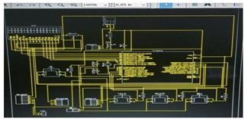

**Fig.7 System Architecture**

Smart Cart using Arduino and RFID is an efficient system when it comes to scanning of products, bill generation and payment. It uses an Arduino chip, a RFID reader, an LCD, buzzers, capacitors, buttons, etc. and also RFID tags to be attached on the products.

The RFID reader shall be used to scan the RFID tags present on the product and all the information received from the tags shall be stored in the Arduino chip. The system shall have 3 buttons- total, delete and bill button. The product can be directly scanned by the reader and if the customer wishes to remove any product, they just have to press the delete button and scan the product again. The product shall be deleted. If the customers wish to see the total, they can press the total button and the total shall be displayed. While making the payment of the bill, the customers just has to press the bill button after connecting the USB to the billing section and their bill shall be automatically generated in the admin’s system.

**PROPOSED METHODOLOGY**

This project brings to market tremendous opportunities for retailers using Radio frequency identification (RFID) technology. Traditionally RFID was used to track inventory along supply chains, retailers placed RFID tags onto pallets. Now with this automated system retailers will recognize the value of tagging individual pieces of merchandise [1]  that will overcome the problem of the product being in the Line of Sight (LOS) of the reader. Item- level RFID tagging is proving to deliver product inventory data that is up to 99.5% accurate.

Retailers will have a precise understanding of their entire inventory and a quick means to assess it. As such, they are equipped to make decisions on which products to carry and which to restock and have an effective means to significantly increase inventory visibility, lower labour costs, decrease operational expenses and slash the high price of shrinkage[3].

The wait is over. With RFID-enabled kiosks and fixtures throughout the store, customers can enjoy speedier checkouts and greater convenience [7]. This line-busting technology can simply communicate with shoppers’ smart phones to complete transactions on the spot via mobile banking. And as customers shop, RFID can collect customer information that retailers can turn into insight to attract them back again and again. The big payoff of RFID is 14%-21% more sales and 19% more units sold.

### **A. Product Registration-**

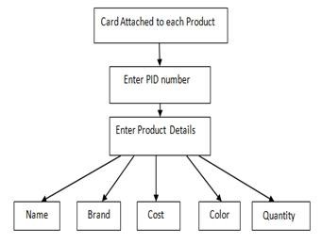

Fig.2 Product Registration

Each product is tagged with passive RFID tags, with a unique product identification number. The details of which need to be added in the database that is done using the product registration form (Fig.1).

Product registration is done at the back end when details about RFID tagged products are added. Details of the product include– name, brand, colour, cost, quantity. All this information is stored in the EEPROM. This stored database is used to maintain the inventory stock and give a notification whenever number of products is below a certain limit.

### 

### **B. User Registration-**

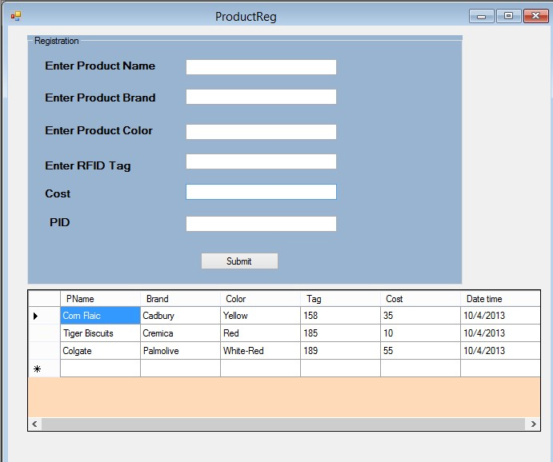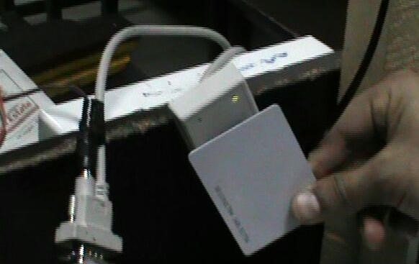

Fig.3 Product Registration Form

When the customer enters the store, they are registered and a RFID credit card is issued to them (Refer Fig.2). This RFID credit card is used for payment to replace cash and hence making payment process fast and customer friendly. At the time of registration there are two possibilities:

* Either the customer is a new customer – In such a case RFID credit card is issued and others user details like name, contact number, email id, card number and amount are entered.

* The customer is an old customer – In such a case card Recharge form is opened and the customer card is recharged with the requested amount.

### **C. Billing –**

Fig.3 Billing Form and adding of Products

When all the purchases which are inside the cart have been scanned by the RFID scanner and the total amount has been stored inside the microcontroller then the cart is connected to the server laptop using MAX 232.

When the cart is authenticated and details of purchased products is transferred from cart to the laptop then the locking mechanism operates and cart is opened automatically. There can be two cases

(i)If the balance is greater than the billed amount then the amount is debited from the card and shopping is complete.

(ii)If the balance is less than the billed amount then user is directed to the recharge or registration section, where the customer can recharge the card with additional amount.

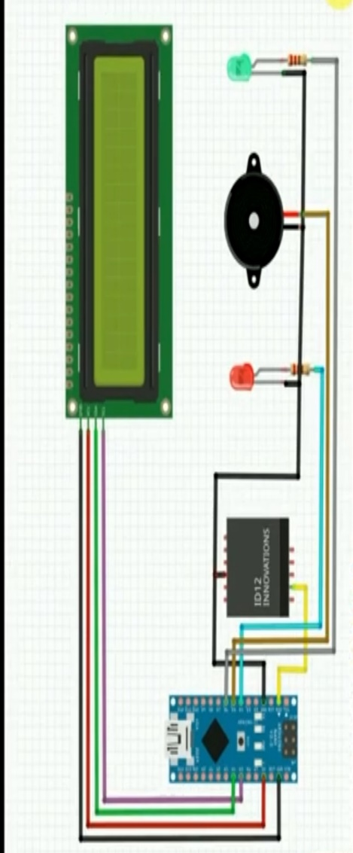 **Circuit Diagram**

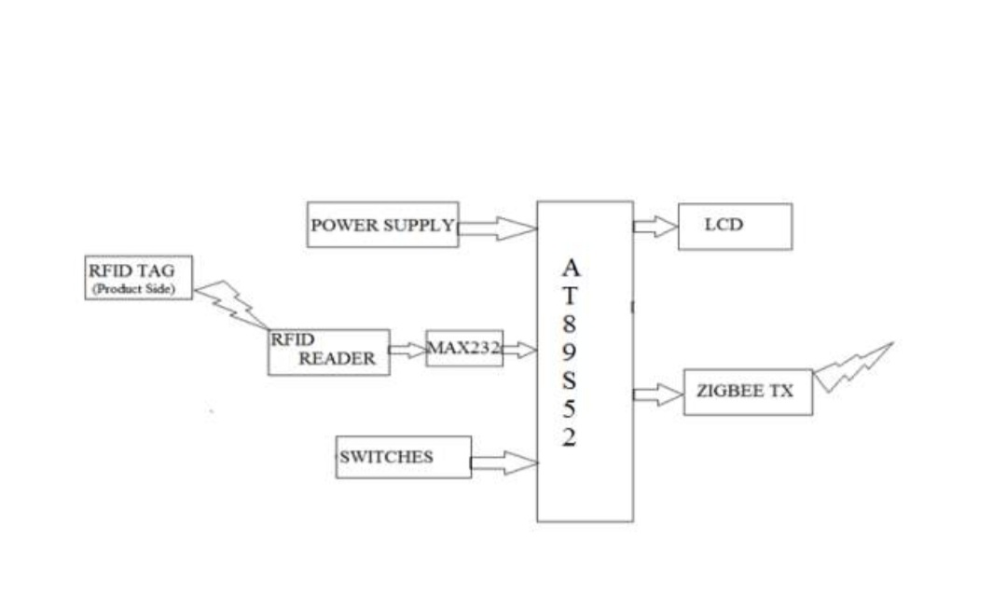 **Block Diagram**

**CONCLUSION**

“Smart Cart using Arduino and RFID” has been successfully implemented. This system is not only effective in eradicating the long queues but also manages the budget of the customer. This system is automated and far better than the existing Barcode system. With new technologies rapidly making every walk of life smart, shopping should be made smarter too. The system also has a very quick and easy billing option.

In this present scenario, The payment of bill by standing in long queue is a tiring factor when people want to purchase commodities from marts. Though people can pay instantly, they are forced to wait in the queue for longer time. The idea which is proposed using RFID technology will overcome the problem and it gives. The combined effects of easy and flexible implementation, secure transmission of account information, and reduced disputes offer the following benefits for all. It will save time, energy and manpower of Customer, Owner and supplier.

* This application creates an automated central bill system for supermarkets and mall.
* There is no need for the customers to wait near the cash counter for their bill payment, since their purchased product information is transferred to central billing system.
* It would also reduce the required number of salesmen. Thus, it is truly a time saving method and uses less time consumption out of all present billing methods.
* The developed product is easy to use, economical and does not require any special training. This project simplifies the billing process. This will take the overall shopping experience to a different level.

**REFERENCE**

[1] G.Roussos and B.College, ―Enabling Rfid in Retail‖ Computer IEEE, vol. 39, no. 3, 2006.

[2] A.Sarac, N.Absi, S.Dauzere-Peres, ―A Literature Review of impact of RFID technologies in Supply Chain Management‖, France, March 2009.

[3] ABI Research, ―RFID Item-Level Tagging in Fashion Apparel and Footwear‖ 4Q, 2009. [4] [4] Ferguson, Renee Boucher. ―Wal-Mart's CIO Dishes on RFID at NRF Tech Conference ‖ E-Week.com, Aug. 9, 2006.

[5] Bill Mc-Beath, The Explosion of Retail Item-Level RFID: A Foundation for the Retail Revolution, April 2013.

[6] Ankit Anil Agarwal, Saurabh Kumar Sultania, Gourav Jaiswal, Prateek Jain.‖ RFID Based Automatic Shopping Cart‖, Control Theory and Informatics Vol 1, No.1, 2011.3

[7] Motorola, Transforming the customer experience with RFID (White Abhishek Verma is currently pursuing his B.Tech. from Chitkara University, Punjab. He is an executive of IETE and member of ISTE. He has won many awards of appreciation for his project like Solar City, Wireless Controlled Pick and Place Robotic Arm. His major areas of interest are Mobile Communication and Embedded.